Ticket to Work
Valuation of key outcomes
August 2020

Executive summary
Ticket to Work is an initiative of National Disability Services that seeks to increase the chances of young people with disability securing ongoing open employment and improve economic and social outcomes. An evaluation of the model in 2019 found, amongst other things, that participants are substantially more likely than a similar comparison group to:
- complete Year 12,
- work in open workplaces,
- participate in the labour force, and
- be involved in social activities.
This report draws on the data from that study to estimate two scenarios: a Ticket to Work scenario and a ‘Business as Usual’ scenario based on data about employment outcomes for young people with disability who did not participate in Ticket to Work. Figure 1 demonstrates the impact of Ticket to Work: far more participants are in the labour force, employed, and in open employment than would otherwise have been the case.
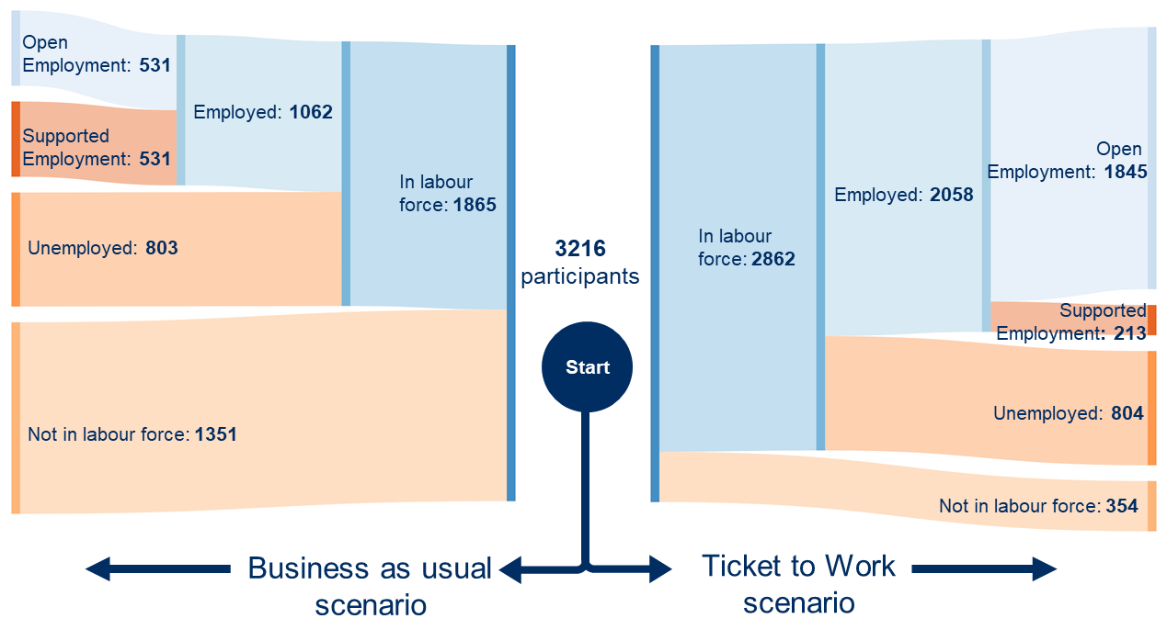
Figure 1: outcomes for the Ticket to Work and Business as Usual scenarios

This report builds on this evaluation to estimate the financial value of these outcomes. It goes through a five-step process to identify these values:
- What outcomes do participants experience as a result of being involved in Ticket to Work?
- What benefits or costs can reasonably be expected to occur as a result of that outcome?
- What fiscal (i.e. government) benefits or costs can reasonably be expected to occur as a result of that outcome?
- How many Ticket to Work participants experienced those outcomes compared to what we would expect to see in a comparable group?
- Calculate the total value of the outcomes for all Ticket to Work participants.

This report estimates that there is an average net benefit of about $27,100 per participant over three years, or about $87.3m across all 3216 participants. That benefit is made up of the following elements:
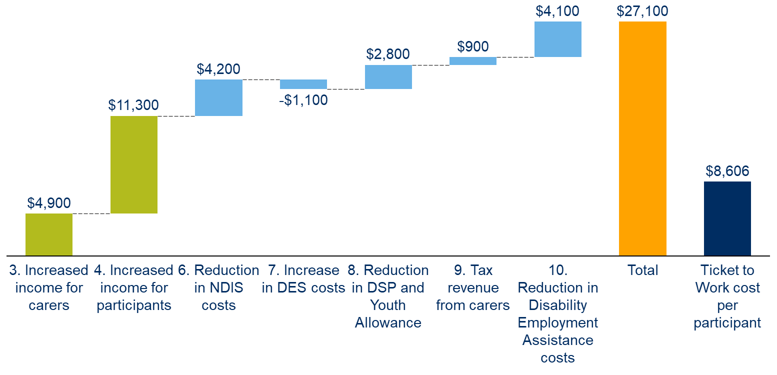
Figure 2: Average Ticket to Work social and fiscal benefits (per participant over three-year impact period, benefits values are rounded to the nearest $100).
Long-term social/economic benefits: Ticket to Work increases incomes for people with disability and their carers. People with disability earn higher incomes because they are twice as likely to work in a paid job, and three times as likely to work in open employment (where wages are generally triple those in Australian Disability Enterprises). Similarly, carers of Ticket to Work participants are able to increase their work hours when the person they care for is at work.
Long-term fiscal benefits: Ticket to Work participants and their carers earn higher wages, so government collects more in income tax revenue, and pays less in Disability Support Pension and Youth Allowance. Fewer Ticket to Work participants work in supported employment at an Australian Disability Enterprise, reducing Disability Employment Assistance grants. This saving is offset by increased expenditure on Disability Employment Support, as those people who would otherwise be out of the workforce or working in an Australian Disability Enterprise are supported to find and keep jobs in the open job market. There may also be reductions in NDIS support to participants if they require fewer supports to participate in social and community events as a result of higher levels of independence and community participation.
This report has taken a conservative approach to estimating these costs and benefits throughout, to avoid overstating the benefits of the Ticket to Work model. In line with its conservative approach, it does not seek to value the non-financial impacts, such as increases in wellbeing, though we note that these effects are likely to be substantial. However, the estimated values rely on data from a survey of 57 program participants and a range of assumptions that are outlined in detail through this report. This data represents a snapshot of the outcomes for these respondents at one point in time. Given the long-term impact of many of the changes identified in this report, more data collected over a longer time period would improve the accuracy of these estimates.

Contents

1. Executive summary 1
2. Definitions and Abbreviations 3
3. Overview of Ticket to Work 4
4. Methodology 7
5. Summary of outcome valuations 13
6. Conclusion 17
Appendix: Calculations 18
Bibliography 38

Definitions and Abbreviations
Term | Abbreviation | Definition
Australian Disability Enterprise | ADE | Not-for-profit organisations providing supported employment opportunities to people with disability.
Disability Employment Assistance grants | DEA | Commonwealth grants to Australian Disability Enterprises for each person with disability who is employed in a supported position.
Disability Employment Services | DES | Commonwealth funds service providers to support people with disability to find work or participate in work-related training.
National Disability Insurance Agency | NDIA | The Commonwealth agency that administers the NDIS.
National Disability Insurance Scheme | NDIS | Insurance scheme that provides support to people with disability, their families, and carers.
Open employment |  | Employment of people with disability in the general labour market. Wages paid to people with disability in open employment may be lower than those paid to people without disability through the supported wage system.
Supported Employment |  | Employment of people with disability in an Australian Disability Enterprise where that job is only open to people with disability. Wages paid to people in supported employment are typically much lower than those paid to people in open employment.
Supported Wage System | SWS | A process that allows employers to pay a productivity-based wage for people with disability that matches an independently assessed productivity rate.

Overview of Ticket to Work
Ticket to Work seeks to connect young people with disability with the world of work before they leave school
Australia has one of the lowest rates of employment for people with disability in the OECD. 53% of Australians with disability are employed, which is much lower than the general population at 83%, increasing the cost to the state of welfare and reducing economic productivity (OECD 2010). At the same time, the absence of these workers from Australia’s workplaces reduces the presence and visibility of people with disability in the community.
Many of the drivers of low labour force participation rates start at school. People with disability are significantly less likely than their peers to complete Year 12, less likely to participate in work experience, and have lower aspirations for post-school work (Athenasou et al. 2019). The education, skills and attitudes developed through school are closely linked to subsequent participation in post-school work or training. In turn, those who participate in work or training are more likely to work, earn more, have more active social lives, and feel more independent than those who are disengaged from work, education, and training.
Ticket to Work is an initiative of National Disability Services. Ticket to Work’s theory of change is:
‘connecting a student with disability with the world of work before they leave school through a coordinated approach, greatly improves their chances of securing ongoing open employment and creates better economic and social outcomes.’
Ticket to Work seeks to address the causes of lower labour force participation by focusing on young people with disability who are still at school. It does this through a combination of school-based vocational and career development, as well as early contact with work environments. Operating since 2014, Ticket to Work has provided about 3200 young people with support for career development and work preparation activities
The model is delivered through 31 local Ticket to Work networks, which typically include schools, employment services, post-school service providers and employers. In total there are about 370 network members, 1900 employers, and 261 schools across those 31 local networks. With an emphasis on evidence-based practice, these networks bring disability-specific and mainstream representatives from a variety of sectors to support young people to gain access to early experiences that:
- positively influence their views of themselves as workers
- prepare them for the workplace
- give them an employment pathway that is typical of other young adults
- increase opportunities for meaningful work experience and learning prior to exiting school
Each Ticket to Work participant takes part in a range of activities that are tailored to their needs. Those activities include:
- Vocational Education and Training at secondary school
- Australian School based Apprenticeships and Traineeships (ASbAT)
- Work experience/ placement
- Career development through customised employment techniques
- After-school work
- Self-employment during secondary school (microbusiness).
The outcomes and impact that these activities are intended to have on the lives of participants are described in Section 5. Together, these activities are intended to build the career aspirations, confidence, and skills of participants.
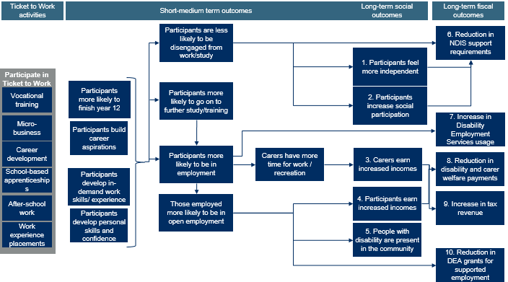
Figure 3: Ticket to Work logic model
Some of the outcomes identified in this logic model were tested through a quasi-experimental study of a sample of Ticket to Work participants conducted by ARTD in 2019. The 2019 Evaluation, along with a more detailed description of the model is available on the Ticket to Work website: tickettowork.org.au. An overview of the key findings of that study shows that Ticket to Work participants were:
- Twice as likely to finish school
- Three times as likely to be in open employment
- 50% more likely to participate in the workforce, and twice as likely to be employed
- Twice as likely to feel they have ‘about the right level of independence’
- Half as likely to be disengaged from work or study

Methodology
This paper seeks to understand the financial impact that Ticket to Work has on people and government
The 2019 evaluation report identified the changes that had occurred as a result of Ticket to Work, but it did not assign a financial value to these changes. This report seeks to extend that analysis by conservatively estimating the financial value to government and individuals from the increase in employment that resulted from Ticket to Work. In line with its conservative approach, it does not seek to value the non-financial impacts, such as increases in wellbeing.
To do this, the report takes five steps:
Step 1 | Step 2 | Step 3 | Step 4 | Step 5
What  outcomes  do participants experience as a result of being involved in Ticket to Work? | What  social and economic benefits or costs  can reasonably be expected to occur as a result of that outcome? | What  fiscal benefits or costs  can reasonably be expected to occur as a result of that outcome? | How many Ticket to Work participants  experienced those outcomes, compared to what we would expect to see in a comparable group? | Calculate  the total value of the outcomes for all Ticket to Work participants

A 2019 study of the impact of Ticket to Work compared the outcomes achieved through the model to the Business as Usual case
The impact of the model was examined through a quasi-experimental study of a sample of Ticket to Work participants conducted by ARTD in 2019. The study compared the outcomes of two groups of people
- Ticket to Work sample: a sample of 57 Ticket to Work participants who have left school
- A ‘business as usual’ comparison group: made up of young people with comparable disability types extracted from the following data sets: (Specifically, the comparison group was defined as people who had left school, were 25 years of age or under, had disability, and had a long-term health condition relating to difficulty learning or understanding things)
- Household, Income and Labour Dynamics in Australia Wave 16 (HILDA) n=69
- 2015 ABS Survey of Disability, Ageing and Carers (SDAC) n=113
- 2015 NDIS Framework Outcomes Pilot Study n=68
The study collected the same data on employment, social participation and independence to allow for a comparison of outcomes that could be attributed to the benefits of Ticket to Work over and above the base case, or business as usual.
The results of this study allows us to estimate the counterfactual ‘business as usual’ case that would have happened for the Ticket to Work participants if they had not participated in the study by applying the outcome proportions calculated in that sample to the entire cohort of Ticket-to-Work participants.
An example of such a comparison is shown at Figure 5 below. In this example, we start with 3216 participants. Of those participants:
- In the business as usual scenario, 1479 would go on to participate in further employment, education, or training. Of those, 739 work, 322 work & study, and 418 study.
- In the Ticket to Work scenario, 2316 go on to employment, education or training. Of those, 1335 are working, 724 work & study, and 247 study.
- Comparing the scenarios allows us to estimate that about 837 more people are in employment, education or training under the Ticket to Work scenario compared to the Business as Usual scenario.
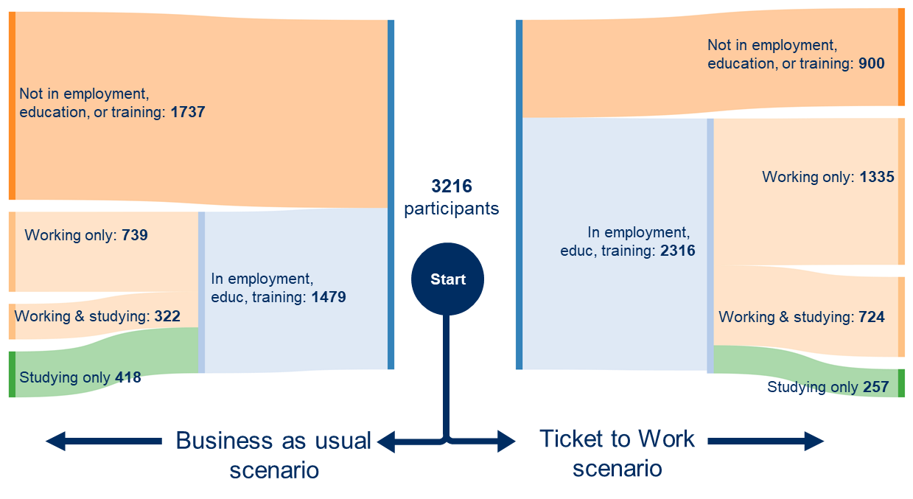
Figure 5: Ticket to Work Scenario comparison for employment outcomes
Limitations
There are a number of limitations to note in this study:
- We have only included those outcomes for which there was a statistically significant difference between the Ticket to Work group and the Business as Usual comparison group. However, the proportions used in this report are the mid-point estimates. The margin of error inherent in estimating population proportions from a small sample mean that the ‘true’ difference between the groups may be somewhat smaller or larger than these estimates.
- Participation in Ticket to Work was voluntary, and not randomised. As such, there is the possibility that there are characteristics of the people who chose to participate in Ticket to Work that might affect the comparability of the two groups.
- The survey of Ticket to Work participants represents a one-off snapshot of outcomes for participants between zero and five years after they left school. As such, it is not possible to estimate whether the differences observed between the participants and the comparison group will persist throughout their lives.
- Ticket to Work takes an individualised approach and participants may use a range of services and supports to create a unique pathway. These include both mainstream and disability supports, we have focus on the typical disability supports that participants utilised for this paper.
- The funding level through NDIS, ADE and DES have recently or are proposed to change. In this study, we have used the funding levels that were available by the Ticket to Work participants at the time they left school.

Approach
This report adapts an approach taken by Lamb & Huo (2017) that examined the lifetime costs of people in the general population not completing school. That study found significant lifetime costs to government ($334,000) and individuals ($616,000) for young people who left school early. It found even larger costs ($411,000 and $1.1m, respectively) for those young people who had become disengaged from study or work by age 24. Reduced wages, and the consequent reduction in taxes and increase in income support payments, account for more than 80% of these costs. Lamb & Huo included the following elements in their model:
- Fiscal Costs
  - Increased reliance on income support
  - Increased incidence of crime leads to increased criminal justice system costs
  - Increased healthcare costs
  - Increased marginal excess tax burden
- Social Costs
  - Reduced wages
  - Increased incidence of crime leads to increased social criminal justice costs
Adapting this approach to the disability context
Whilst many of the benefits and costs of getting people with disability into work (through education and training) are similar to those proposed by Lamb & Huo, there are additional elements that are specific to young people with disability. These include:
Income measures:
- Disability-specific income support payments: many people with more significant disability and their carers receive certain income support payments, including the disability support pension, youth allowance (with disability supplement) and carer allowance. These supports are typically means-tested, and may be affected by increases in employment income.

- Flow-on impacts for carers: employment for people with disability can have a significant impact on the primary carers of people with disability. The Productivity Commission, NDIA, and others have noted in their analysis of the impact of employment supports in the NDIS that caring responsibilities can limit carers’ ability to participate in paid employment (PC 2011, PWC 2011, Deloitte 2015, NDIA 2018). As such, an increase in participation in employment by people with disability could also increase the ability of their carers to take on additional paid work (NDIA 2018, PC 2011).

Government program expenditure:
- Disability Employment Support (DES): the Commonwealth funds service providers to support people with disability to participate in employment and training. The direction of the impact is unclear; an increase in workforce participation by people with disability may increase these payments (as a result of an increase in workforce participation) or decrease these payments (where people with disability stay in work for longer periods, reducing the need for ongoing support).
- Disability Employment Assistance grants: the Commonwealth provides grants to Australian Disability Enterprises that employ people with disability in supported employment for each employee for each month employed. If there is an increase in the proportion of people with disability entering open workplaces (where these grants are not provided) we would expect to see a reduction in expenditure on Disability Employment Assistance grants. Note that DEA grants are being rolled into the NDIS and there is a proposed new funding rate.
- Changes to NDIS usage: many NDIS plans include expenditure on supports to help people with disability participate in community and social activities (NDIA 2019). As noted above, employment has significant impacts on people’s wellbeing, which may lead to a change in the support required by a person with disability. In particular, increases in employment (and the associated social interactions) may reduce the need to access group-based community and individual support to meet social needs. And increases in independence and social connections may reduce the need for funded individual supports to participate in social activities.

Based on the above, we expanded the model developed by (Lamb and Huo 2017) to incorporate these elements. The components of the model we propose are:
Social and economic benefits

Reference: Description
Outcome 1 People with Disability feel more independent
Outcome 2 People with Disability increase social participation
Outcome 3 Increased income for carers
Outcome 4 Increased income for participants
Outcome 5 People with Disability increase presence in community

Fiscal benefits
Outcome 6 Reduction in NDIS costs
Outcome 7 Increase in Disability Employment Support costs
Outcome 8 Reduction in Disability Support Pension and Youth Allowance
Outcome 9 Increase in tax revenue
Outcome 10 Reduction in Disability Employment Assistance costs

In addition, there are a range of impacts that are likely to be significant, but for which there is insufficient data to reliably estimate a financial value:
- Health: Whilst Lamb & Huo (2017) project the lifetime impact on the health system of school completion, there is less data about this relationship for people with disability. There are likely to be negative consequences of long-term youth unemployment on mental and physical health. The size and scale of these impacts for people with disability are still being investigated by researchers, so are not included in this model (Some Ticket to Work participants are part of the Yes Employment Study by Associate Prof Milner et al at the University of Melbourne. This study examines the links between health and employment for people with disability and is currently in its recruitment phase).
- Criminal justice: Lamb & Huo (2017) estimate that people in the general population who do not complete year 12 are significantly more likely to come into contact with the criminal justice system, both as a perpetrator and victim. There are significant costs to government and society that result from this, which those authors estimate to be about $100 (fiscal) and $400 (social). Less detailed information about those costs for people with disability is available. However, we do know that people with disability are equally or more likely to be the victims of crimes, and to be imprisoned (ABS 2016, AIHW 2018). Applying the values used by Huo and Lamb to Ticket to Work revealed a net benefit of about $160 per participant in Ticket to Work. In light of the uncertainty about the valuation of these costs for people with disability, and that the value was quite low, we have chosen not to include this element in the benefit analysis.
- Individual wellbeing: employment has a major impact on the sense of wellbeing for people with disability. Yu (2009) estimated that these wellbeing effects are worth more to people with disability than the income generated from that employment. As such, the size of these benefits is likely significant. However, in line with the conservative approach to valuation adopted in this report, these benefits have not been estimated due to the inherent difficulty in placing financial value on these concepts. As a result, these are not included in this model.

Early Intervention has life-long impacts
Completing Year 12 and entering work or training have life-long impacts on income and wellbeing. Completing school and undertaking work experience while at school can accelerate the transition from school to work and reduce periods of unemployment. Shortening the length of periods out of the workforce will significantly reduce a young person’s risk of long-term economic insecurity and labour market marginalisation (FYA 2016) (2019 Evaluation report p20 for a more detailed discussion)
For an unemployed person with disability, completing a training course at Cert III and above increases the likelihood of getting a job from 9 per cent to 29 per cent - a significant increase in employability. In comparison, for someone who is unemployed and does not have a disability, completing training increases the likelihood of employment from 52 per cent to 62 per cent - a 10 per cent increase for people without disability compared with twice the impact for people with disability (Polidano et al. 2010).
Participation in VET apprenticeships and traineeships for people with a disability result in high workforce participation rates and income post training - comparable with similarly-aged Australians without disability. A longitudinal study of apprentices and trainees with disability found that 87 per cent of the participants were in paid work a year after graduation. Whereas participation by people with disability in apprenticeships and traineeships remains very low at 2 per cent (Cocks and Thoresen 2013).
This is also borne out by international longitudinal research that shows certain in-school programs for people with disability have long-term impacts on the likelihood that a person will be employed. For example, analysis of the US National Longitudinal Transition Study showed the impact of in-school initiatives on the likelihood of being employed over a period of 10 years (Park & Bouck 2018). The authors found that the following initiatives (which are similar to those provided by Ticket to Work) were predictive of employment at follow-up:
- job readiness vocational services: 7.36 times more likely to be in paid employment than those who did not receive these services
- instruction in looking for jobs: 7.95 times more likely to have paid employment than those who did not receive the instruction
- individuals who receive placement support: 5.37 times more likely to be in paid employment
- transition plans included open employment: 3.71 times more likely to be in paid employment
We have conservatively calculated the benefits over a three-year period, but the life-long benefits are likely much larger
Whilst the secondary research above indicates that these impacts are likely to persist over many years (and potentially life-long), the sample data from the 2019 evaluation report covers participants who have completed Ticket to Work activities within the last few years. In particular, Ticket to Work survey respondents had worked for an average of 1.9 years after completing school, and up to a maximum of five years. As such, in line with our conservative posture, we can be confident that the data is indicative of Ticket to Work’s impact over a period of at least three years after a young person finishes school. However, for completeness, a sensitivity test was conducted to estimate the value of the outcomes if they did persist over 10 years.
Some valuation methodologies (notably, Social Return on Investment) include discounts to the calculated impact to account for drop-off (decline in a program’s impact over time) and deadweight (contribution of other programs to the impact). In light of the fact that the data uses a comparison group as a counterfactual, and that the data reflects average outcomes for people over a three year impact period, we have assumed that these rates are zero. We have used 2019 dollar values for outcomes throughout.

Summary of outcome valuations
The following figure shows (in orange) the long-term outcomes of Ticket to Work that have been valued. It also shows the estimated value per person over the three-year impact period. The calculation steps for these numbers are explored in the appendix.
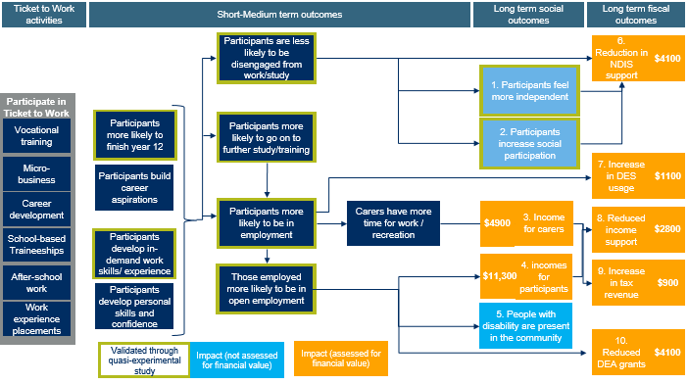
Figure 6: Program logic model showing the impacts that have been valued, and the estimated value of those impacts over the three-year benefit period
These calculations estimate that the total social and fiscal benefits of the Ticket to Work model, calculated over a three-year impact period are about $27,100 per participant. The constituent elements of that benefit per participant are:
Long-term social/economic outcomes:
- $4,900 in additional income for carers from increasing work hours
- $11,300 in increased income for people with disability as a result of being more likely to work, and more likely to work in open employment where wages are higher
Long-term fiscal outcomes
- $4,200 reduction in NDIS expenditure on community social supports as a result of participants meeting more of their social needs through work and study
- $1,100 increase in Disability Employment Services (DES) as a result of participants being more likely to participate in the workforce and therefore more likely to need support to find and keep a job
- $2,800 reduction in income support payments as a result of reductions in disability support payments to participants who earn more (assuming no change to carer payments)
- $4,100 reduction in Disability Employment Assistance grants as a result of fewer participants working at an Australian Disability Enterprise
- $900 increase in tax revenue as a result of carers increasing work and earnings
These impacts are summarised in the following diagram:
Figure 7: elements of social and fiscal benefits
Comparison with other studies
To test whether this is a reasonable estimate of the impact of Ticket to Work model, is outlined in a summary of work done by other researchers to calculate the economic value of increasing employment amongst people with disability in Australia. These papers were prepared to examine the productivity impact a broad package of NDIS reforms will have by enabling people with disability and their carers to enter work or increase their working hours.
These models differ from ours in the following important ways:
- They calculate the nation-wide effects of large policy changes using economic models.
- The methodology of some of these approaches is unclear, but most have used multipliers. Amongst other things, these multipliers include the downstream jobs and productivity that are created as a result of people being in employment. Following the advice of a Productivity Commission paper we have chosen not to include multipliers in our calculations.
- With their macro-policy focus, these papers express changes in terms of their impact on GDP. Given the small scale of Ticket to Work, we have recalculated these to an average GDP increase per additional full-time-equivalent (FTE) to facilitate easier comparison.
Estimates of GDP impact of NDIS participants in Employment
Productivity Commission (2011) at pp 960-963
- Increasing employment by 100,000 People with Disability by 2050 will increase GDP by about $8bn.
- $35,000 increase in annual GDP per person with disability FTE (2019 dollars (assuming a 2.8% inflation rate)
National Disability Insurance Agency (2018)
- Increasing employment of people with disability and their carers by 117,000 by 2030 will increase GDP by $11.9bn
- $75,000 per carer or person with disability FTE (2019 dollars)
Deloitte Access Economics (2011)
- GDP increase of $21.9b with an increase of 143,000 FTEs = $153k per additional FTE
- $110,000 per person with disability FTE (2019 dollars)
NDS (2011)
- $9.6bn from 35,000 new FTE jobs
- $274,000 per person with disability FTE (2011 dollars)
CSU (2015)
- $7-11bn from 25,000 to 40,000 new people with disability FTE jobs $11bn from 34,000 new carer FTE jobs
- $280,000 per person with disability FTE. $324,000 per carer FTE (2015 dollars)
The numbers above are not directly comparable to the impact calculated in this paper because those values calculate the annual GDP impact per FTE employed, whereas this paper calculates the impact per program participant over three years. However, they do indicate that our estimate of the impact of the program is likely conservative.
Sensitivity testing
The estimates of value provided in this report rest on a range of assumptions. Five sensitivity tests are set out below, with more detail on the calculation of these tests in the appendix.
Sensitivity Test
Base case- Valuation $27,100
- 80% of participants have NDSI plan (from 56% in base case)- valuation $28,800
- There is a similar (10%) reduction in usage of NDIS group and individual supports as a result of increased work and independence (from 30% individual and 50% group in base case)- valuation $23,900
- Impact persists for 10 years with a 10% drop-off rate, and 6.5% social discount rate- valuation $50,000

Conclusion
Ticket to Work has an estimated average social and fiscal benefit of about $27,100 per participant over the three-year benefit period. Wherever possible, we have made conservative assumptions, so this is likely an underestimate of the impact of the program. Most significantly, many of the impacts of completing year 12, and transitioning smoothly into further work or study are likely to persist throughout life. Therefore, whilst we have estimated the benefits over a conservative three-year period, the life-long benefits may be larger.
The constituent elements of the benefits are set out in the table below.
Estimated benefit (cost) over three years (figures rounded to the nearest $100 or $100,000, so there may be variances in row and column totals)
 | Basic (cost) element | Per participant | All 2316 participants
Social and economic benefits | Long-term outcome 1: People with Disability feel more independent | Not estimated | Not estimated
Social and economic benefits | Long-term outcome 2: People with disability increase social participation | Not estimated | Not estimated
Social and economic benefits | Long-term outcome 3: Increased income for carers | $4,900 | $15.7m
Social and economic benefits | Long-term outcome 4:  Increased income for participants | $11,300 | $36.5m
Social and economic benefits | Long-term outcome 5:  People with Disability increase presence in community | Not estimated | Not estimated
Fiscal benefits | Long-term outcome 6:  Reduction in NDIS costs | $4,200 | $13.5m
Fiscal benefits | Long-term outcome 7:  Increase in DES costs | ($1,100) | $3.4m
Fiscal benefits | Long-term outcome 8:  Reduction in DSP and/or Youth Allowance | $2,800 | $8.9m
Fiscal benefits | Long-term outcome 9:  Tax revenue from carers | $900 | $3.0m
Fiscal benefits | Long-term outcome 10:  Reduction in Disability Employment Assistance costs | $4,100 | $13.2m
Total |  | $27,100 | $87.3m
Figures rounded to the nearest $100 or $100,000, so there may be variances in row and column totals

Appendix: Calculations

Long Term Outcome 1. Participants feel more independent
Financial value not estimated

Long Term Outcome 2. Participants increase social participation
Financial value not estimated

Long Term Outcome 3. Carers Earn Increased Incomes
Long Term Outcome 3: what outcomes do participants experience as a result of being involved in Ticket to Work?
There is extensive evidence to indicate that the many primary carers of people with disability want to increase their workforce participation. However, carers are often unable to do so because of the care needs of the person they care for. Research from the NDIA (2018), Productivity Commission (2011), Deloitte Access Economics (2011), and PWC (2012) has indicated that the NDIS rollout will enable carers to return to work or increase their work hours as a result of reduced care responsibilities.
We adopt a similar approach here, working from the assumption that an increase in the working hours of a person with disability will mean that carers may also be able to increase their work hours. The NDIA is actively researching the extent to which carers are actually returning to work as a result of the NDIS. Early research indicates that there has been a small increase in the number of carers who have increased work (NDIA 2018).
Long Term Outcome 3: what benefits or costs can reasonably be expected to occur as a result of that outcome?
Carers were not interviewed as part of the 2019 ARTD evaluation, and no comparison group was established. As such, it is necessary to extrapolate the likely impact on carers from other research. For carers the key assumptions are:
Group | Assumption | Source
Carers | 47% of carers want to work more, but are prevented from doing so by care responsibilities | 52% of family members would like to work more, 91% of whom are prevented from doing so by care responsibilities (NDIA (2019)). Calculated as 91% of 52%.
Carers | 94.8% of carers who want to work more are able to find work | Inverse of 5.2% general unemployment rate (ABS 2019b)
Carers | Carers earn $31.93 per hour of additional work ($29.16 plus 9.5% superannuation) | Carers are typically older and are experienced in the workforce. We assume they earn 70% of average weekly earnings (converted to an hourly rate) (ABS 2019a). Long (2015) assumed average weekly earnings in his modelling for carer employment, but we have adopted a slightly more conservative approach.
Carers | Carers who are able to work more increase their own work hours by half the amount that the person they care for works | We know from NDIA (2018) that 75% of carers already work more than 15 hours per week, so work hour increases are likely to be moderate. This is more conservative than Long (2015), who estimated approximately 1:1 ratio of FTE carer to person with disability employment changes.
Carers | Carers pay a marginal tax rate of 19.5% | Marginal tax rate for someone earning average weekly earnings (ATO 2019)
Carers | No change to carer support payments | The eligibility rules for carer support payments rely on an array of factors, including residence status of the person with disability, assets, and spouse income.
Carers | One carer per person with disability is able to increase work hours | Whilst many people with disability have multiple carers, our model assumes only one of these carers is able to change work habits as a result of the person with disability going to work. Again, Long (2015)’s model shows a 1:1 FTE ratio of employment between carers and people with disability, so this assumption is likely reasonable.

Long Term Outcome 3: how many Ticket to Work participants experienced these outcomes, compared to what we would expect to see in a comparable group?
Using the assumptions in the previous section, the following table calculates that 475 carers in the ‘business as usual’ scenario would increase their work hours, compared to 826 in the Ticket to Work scenario. In other words, about 350 additional carers were able to increase their work hours as a result of participation in Ticket to Work.
The difference between these numbers is driven by the larger number of Ticket to Work participants who are working (and therefore enabling carers to increase work hours).
Business as usual
  - PWD who work: 1,061
  - Carers who want to work: 503
  - No. who are able to increase hours: 475
Ticket to Work
  - PWD who work: 2,058
  - Carers who want to work: 974
  - No. who are able to increase hours: 921
Long Term Outcome 3: calculate the additional benefit generated by Ticket to Work
The following table sets out the anticipated amount of income earned and tax paid for a carer who increases work hours as a result of the person they care for taking up work. The difference between the average increase in work hours per week is driven by the fact that Ticket to Work participants are more likely to be in open employment, and work fewer hours than the business as usual participants.
Business as usual
  - Hourly rate (inc super): $31.93
  - Weighted avg. increase in work: 9.51
  - Annual increase in income (net of tax) per carer who increases work: 15,800

Ticket to Work
  - Hourly rate (inc super): $31.93
  - Weighted avg. increase in work: 8.33
  - Annual increase in income (net of tax) per carer who increases work: 13,800

The following compares the net increase in income and tax for carers in both the ‘business as usual’ and ‘Ticket to Work’ scenarios.
Increase in net income for carers over three years
- Business as usual: 7000 average per participant
- Ticket to Work: 11,900 average per participant
- Difference: 4,900 average per participant

Compared to the business as usual case, carers earn about $15.7m more from increasing their work hours, or an average of about $4900 per Ticket to Work participant over the three-year benefit period.

Long Term Outcome 4. People with Disability earn increased incomes
Long Term Outcome 4: what outcomes do participants experience as a result of being involved in Ticket to Work?
From the Ticket to Work (2019) evaluation, we know that participants in Ticket to Work are more likely than a comparison group to:
- finish year 12
- have enough work experience, and
- go on to further study.
Together, they contribute to an increase in the likelihood that a Ticket to Work participant will be employed, and that participants will be employed in an open workplace. These results were validated through the 2019 evaluation report. And in longitudinal studies conducted overseas, these three elements have been also found to increase employment participation.
Long Term Outcome 4: what benefits or costs can reasonably be expected to occur as a result of that outcome?
Participants in Ticket to Work are likely to see an increase in wage earnings as a result of:
- being more likely to be in paid work; and,
- being more likely to work in open employment (where wages are higher than in supported employment).
The assumptions underlying the income changes for this group are as follows:
Group | Assumption | Source
People with disability in open employment | People in open employment work an average of 16 hours per week. | Ticket to Work survey- average number of hours that Ticket to Work participants worked
People with disability in open employment | People in open employment earn an average of $14.71 per hour. This is the average of those earning minimum wage for a 19 year old, and those on a supported wage. | Ticket to Work survey- percentage of Ticket to Work participants who earned the minimum wage
People with disability in open employment | All earning less than minimum wage earn 80% of the minimum wage | Aligns with the underlying assumptions of the Productivity Commission (2011)
People with disability in supported employment | 100% of supported employment workers earn $5.61 per hour | Average ADE wage (DSS, 2018)
People with disability in supported employment | 100% work an average of 10 hours per week | Average for supported employment workers in Ticket to Work survey
All people with disability | Only sources of income are from employment and the disability support pension | Tax rates are calculated on the basis that there are no other income sources

Long Term Outcome 4: how many Ticket to Work participants experienced these outcomes, compared to what we would expect to see in a comparable group?
There are four categories of labour market status that we are interested in:
- In open employment
- In supported employment
- In the labour market, but unemployed
- Not in the labour market
Figure 8 shows the number of people in each of these categories in the ‘Business as usual” scenario, compared to the “Ticket to Work’ scenario.
Figure 8: outcome scenarios by employment type
Long Term Outcome 4: calculate the additional benefit generated by Ticket to Work
The following table sets out the income sources and tax payments for participants in each of the four groups, calculating the net personal income for each group:

Participant outcome and welfare support status | Annual net wages | Govt pensions and allowances | Net personal Income
All in open employment
youth allowance | 13,439 | 10,001 | 23,440
DSP | 13,439 | 19,624 | 33,062
no pension or allowance | 13,439 | - | 13,439
All in supported employment | -
youth allowance | 3,194 | 11,170 | 14,364
DSP | 3,194 | 24,081 | 27,276
no pension or allowance | 3,194 | - | 3,194
All unemployed
youth allowance* |  | 11,170 | 11,170
DSP |  | 24,081 | 24,081
no pension or allowance |  | - | -
All not in labour force
youth allowance* |  | 11,170 | 11,170
DSP |  | 24,081 | 24,081
no pension or allowance |  | - | -
*Youth allowance is only payable to those looking for work or studying
The following multiplies the net personal incomes of each of those groups by the number of people in that group for both the ‘business as usual’ and ‘Ticket to Work’ scenarios.
Increase in net income for participants over three years
Business as usual:
- Entire cohort: 169.3m
- Average per participant: 52,700
Ticket to Work
- Entire cohort: 205.8m
- Average per participant: 64,000
Difference
- Entire cohort: 36.5m
- Average per participant: 11,300

Over the three year impact period, Ticket to Work participants are estimated to have earned a total of $36.5m more than they would have under the ‘business as usual’ scenario. This is about $11,300 per participant over three years.
Long Term Outcome 5. People with Disability are present in the community
Financial value not estimated

Long Term Outcome 6. Reduction in NDIS support
Long Term Outcome 6. What outcomes do participants experience as a result of being involved in Ticket to Work?
Ticket to Work participants are significantly less likely to be disengaged from education, employment or training compared to a comparison group. In addition, Ticket to Work participants are much more likely to feel they go out as often as they wish and participate in social activities. We speculate that there are two flow-on effects from this:
- There is a reduction in the use of NDIS group-based community support programs. As people with disability are engaged for a large part of the week in work, we anticipate that they will need to use a smaller number of hours of group-based community supports.
- There is a reduction in the use of individual NDIS support workers to meet social needs through community participation. This is the result of people with disability feeling more independent and going out more.
Unfortunately, there is little academic research into the link between independence and the use of NDIS supports. As such, these effects are estimated using a limited sample of 57 survey respondents to the Ticket to Work survey over a short period of time. More accurate estimates of this relationship will be able to be developed as further research is conducted into the NDIS and its data.
Long Term Outcome 6. What benefits or costs can reasonably be expected to occur as a result of that outcome?
The survey data collected for the evaluation of Ticket to Work did not ask respondents about their NDIS plan usage. Nor is there data from the NDIS or other researchers that explores the relationship between employment, independence, and usage of NDIS community participation supports. As such, we are required to estimate the likely impact from other sources.
As shown in Figure 9 below, Ticket to Work participants are much more likely to be engaged in certain forms of community participation, when compared to a similar cohort from the Survey of Disability, Ageing and Carers.
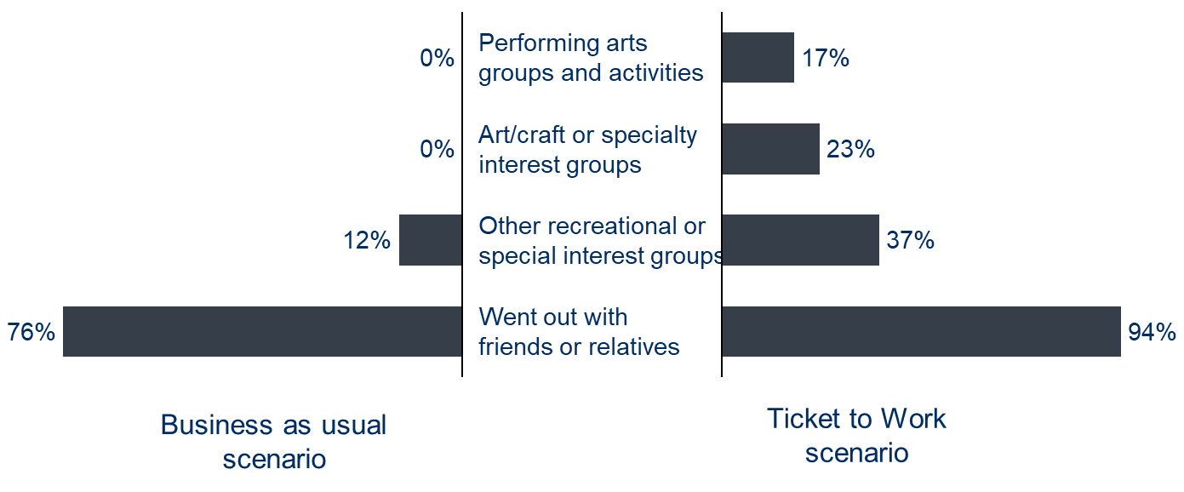
Figure 9: Percentage of respondents who had participated in certain social and community activities.
This figure only includes those activities for which there was a statistically significant difference between the Ticket to Work group and the comparison group
Similarly, Figure 10 shows that Ticket to Work participants are about twice as likely to say they have levels of independence that are “about right” compared to a similar cohort of respondents to the NDIS Framework Outcomes Pilot Study.
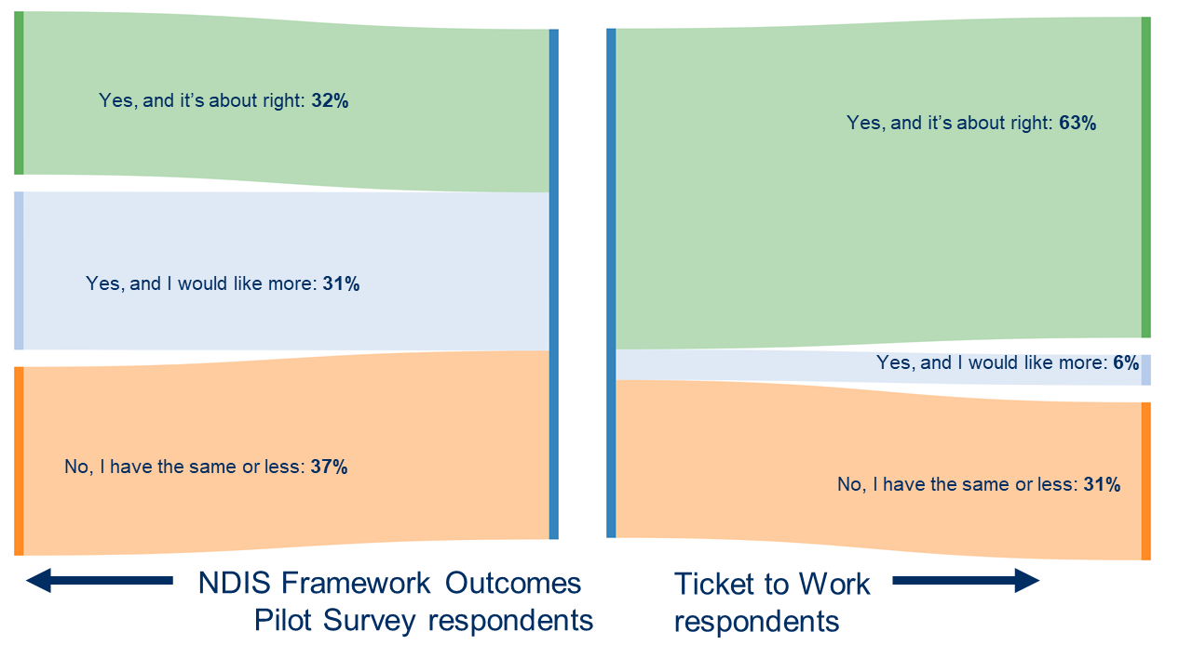
Figure 10: responses to ‘do you have more independence than you did two years ago?’
Ticket to Work participants have substantially higher levels of social and community participation. We are proposing that this is driven by social opportunities afforded through higher levels of participation in open employment and education. To estimate the possible cost savings for the NDIS, therefore, we hypothesise that:
- People who are employed use fewer hours of group-based community programs because they meet more of their social and community needs through work. For each hour of work, they use 30 fewer minutes of group-based supports.
- People who “go out as often as desired” use about 30% fewer individual community participation supports than those who “go out, but not as often as desired” because this group is more likely to be able to meet those needs independently of NDIS support.
We also considered an alternative hypothesis that an increase in the sense of independence by people with disability may increase their likelihood of going out, and thereby increase their use of NDIS individual supports to facilitate that. However, Ticket to Work staff indicated that anecdotal evidence from participants was that participants were more likely to participate in social activities without supports. This is supported by data from the evaluation survey of Ticket to Work participants which found no substantial difference in perceptions of independence between those that have an NDIS plan and those who don’t:
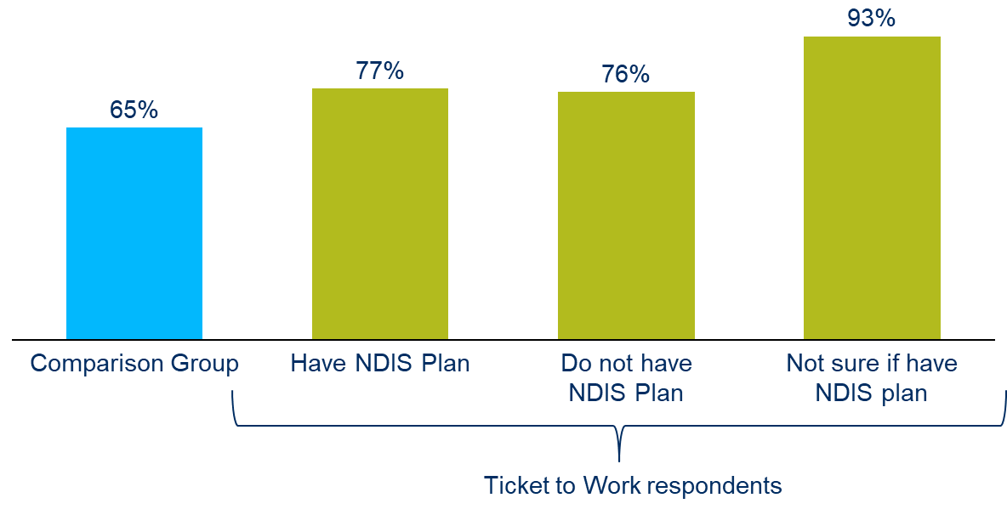
Figure 11: Percentage of survey respondents who go out as often as desired, by NDIS plan status
The effect of these assumptions is summarised in the following table.
 | Outcome | NDIS plan usage
Has NDIS Plan | Employed | Use an average of 0.5 hours per week of group-based social and community participation supports
Has NDIS Plan | Not employed | Use an average of 8.5 hours per week of group-based social and community participation supports
Has NDIS Plan | Go out as often as desired | Use an average of 2.9 hours per week of individual social and community participation supports
Has NDIS Plan | Do not go out as often as desired | Use an average of 4.1 hours per week of individual social and community participation supports
Does not have NDIS plan | All outcomes | None

The cost savings are dependent on the assumptions outlined above, so we have included a sensitivity test at the end of this section that test the revised assumption that those who are employed or go out as often as desired use only 10% fewer NDIS supports.
Other assumptions underlying the income changes for this group are as follows:
Group | Assumption | Source
All | - 54% of participants had an NDIS plan that includes group or individual community supports | - 39% of the respondents to the Ticket to Work survey had an NDIS plan, 30% did not, and 31% did not respond or were unsure. Percentage calculated from those who knew their NDIS plan status. (The NDIS was still in its rollout phase during 2018, when that data was being collected. It’s reasonable to assume that the proportion of participants with an NDIS plan would be higher in the future)

Long Term Outcome 6. How many Ticket to Work participants experienced those outcomes, compared to what we would expect to see in a comparable group?
Group Supports
We assume that the reduction in the use of group-based community and individual supports is based on whether participants are taking part in education, employment or training. As shown in Figure 12 below, 2316 Ticket to Work were engaged in these activities, compared to 1479 in the business as usual scenario.
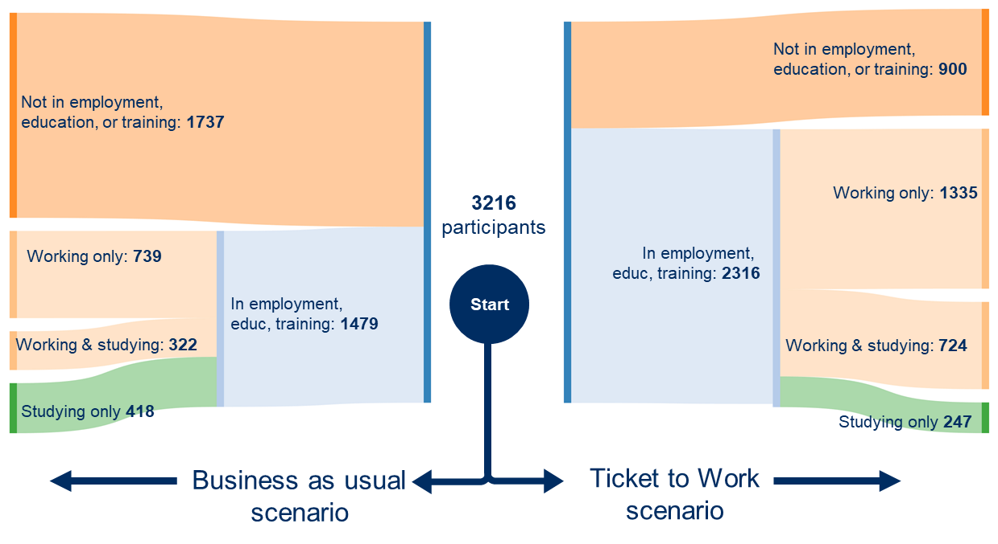
Figure 12: Ticket to Work Scenario comparison for employment outcomes
Individual supports
We assume that individual support usage is driven by the person with disability’s sense of independence: if they feel more independent they are less likely to access NDIS supports to meet their social needs. About 2669 Ticket to Work participants feel a sense of independence (measured by going out as often as desired), compared to the comparison scenario in which 2090 people feel the same.

Long Term Outcome 6. Calculate the additional benefit generated by Ticket to Work
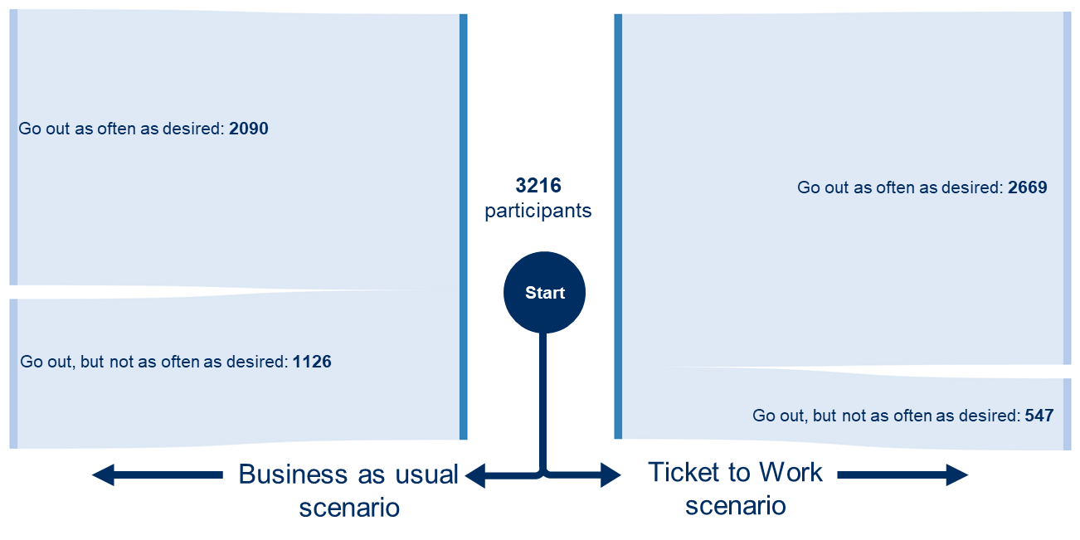
Figure 13: Ticket to Work Scenario comparison for independence outcomes
How much NDIS support do participants receive: To understand the impact on individual and group community participation supports, we first need to know how much of these supports NDIS recipients are accessing. Whilst the NDIA does not publish average amounts of support by support categories, it has previously reported in the NDIS 1st quarterly report to the COAG Disability Reform Council: 2016-17 Q1 at figure 2.11 at National Disability Insurance Scheme that 18.5% of committed supports are for core community supports and social/civic participation supports. The average plan value for a person with intellectual disability is about $95,000, implying that average community participation supports may be approximately $17,575 this estimate could be improved with more granular data from the NDIS. (NDIS National Dashboard as at 30 June 2019 at p9 at www.NationalDisabilityInsuranceScheme.gov.au
But for the purposes of this report we assume that the average participant receives about 8.5 hours of group-based supports and 4.1 hours of individual supports, for a total of $17,575 at NDIS’s 2019 hourly rates for these supports.
NDIS support type:
- Group based: 8.5hrs of support/week, $17.97 per hour support cost and $7,910 committed support amount
- Individual supports: 4.1hrs of support/week, $45.54 per hour support cost and $9,665 committed supported amount
- Total: $17,575
What impact do our assumptions have on per-person NDIS usage: The financial impact of our hypothesis that those in employment access fewer group-based supports is summarised in the following table. If a participant has an NDIS plan, expenditure on group-based supports for those in employment is assumed to be $410 per annum, compared to $7,910 per annum for those not in employment, education, or training. The difference is driven by our assumption that those who work reduce their access to group programs by 30 minutes for each hour they work.
Participation type
Engaged in Employment, Education or Training
- Have NDIS plan
  - 0.5 hours group based programs
  - $410 annual cost group based programs
- Does not have NDIS plan
  - 0 hours group based programs
  - $0 annual cost group based programs
Not Engaged in Employment, Education or Training
- Have NDIS plan
  - 8.5 hours group based programs,
  - $7,910 annual cost group based programs
- Does not have NDIS plan
  - 0 hours group based programs
  - $0 annual cost group based programs

Similarly, the shows the financial impact of our assumption that those who ‘go out as often as desired’ access fewer hours of individual supports. Those with an NDIS plan who ‘go out as often as desired’ use $6,770 on individual supports, compared to $9,670 for those who do not go out as often as desired.
Participation type
Go out as often as desired
- Have NDIS plan
  - 2.9 hours individual supports per week
  - $6,770 annual cost individual supports
- Does not have NDIS plan
  - 0 hours individual supports per week
  - $0 annual cost individual supports
Don’t go out as often as desired
- Have NDIS plan
  - 4.1 hours individual supports per week
  - $9,670 annual cost individual supports
- Does not have NDIS plan
  - 0 hours individual supports per week
  - $0 annual cost individual supports

What is the impact of these changes for the whole cohort: We now apply the per-person changes to the whole cohort in the business as usual and Ticket to Work scenarios. Over the three-year impact period, Ticket to Work participants are estimated to use a total of $13.5m less in NDIS supports than the they would have under the ‘business as usual’ scenario. This is about $4200 per participant over three years.

Reduction in NDIS Social and Community Supports over three years
Business as usual
  - Entire cohort $66.6m
  - Average per participant $20,700
Ticket to Work
  - Entire cohort $53.2m
  - Average per participant $16,500
Difference
  - Entire cohort $13.5m
  - Average per participant $4,200

Long Term Outcome 7. Increase in Disability Employment Support usage
Long Term Outcome 7. What outcomes do participants experience as a result of being involved in Ticket to Work?
Disability Employment Services (DES) payments are made by the government to service providers to assist people with disability to find and keep a job. DES payments are only payable for people assessed as being capable of working at least 8 hours per week, and are not available for people working in an ADE or in study. These payments include a range of ongoing service fees, as well as outcome fees for people with disability who are placed in work. There are three broad groups of assistance:
- Employment Assistance is provided to people with disability looking for jobs,
- Post-Placement support is provided for people in the year following the start of a new job, and
- Ongoing Support may be provided if required.
The sequencing of these support phases, along with the payment rates, are set out in the diagram below. A former DES participant that longer requires support to maintain or find a job is an independent worker.
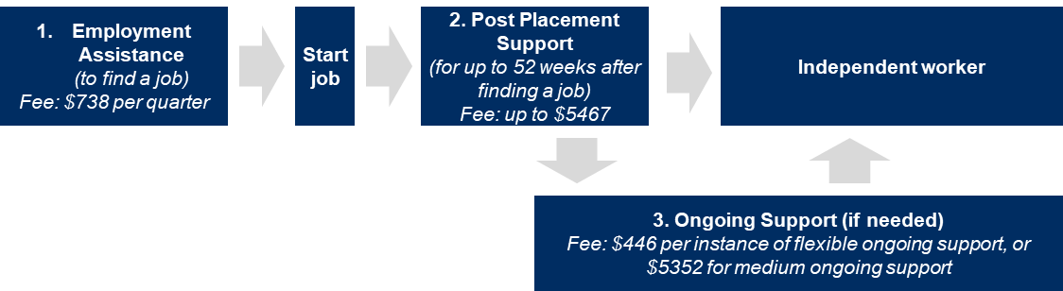
Figure 14: Phases of DES support to job seekers
Figure 15 below shows that some 92% of participants are in the Employment Assistance or Post-Placement phases of DES support. In contrast, relatively few Ticket to Work DES recipients are in these phases: about 70% are in the Ongoing Support phase, indicating progress towards independent work. (Ticket to Work data calculated by the Department of Social Services in December 2017. All DES recipient data is from the 30 September 2019 DES Monthly Tracking Data available from Disability Employment Services data. The comparison group is all people with disability, because data is unavailable for a more comparable group (under 25 with intellectual disability).
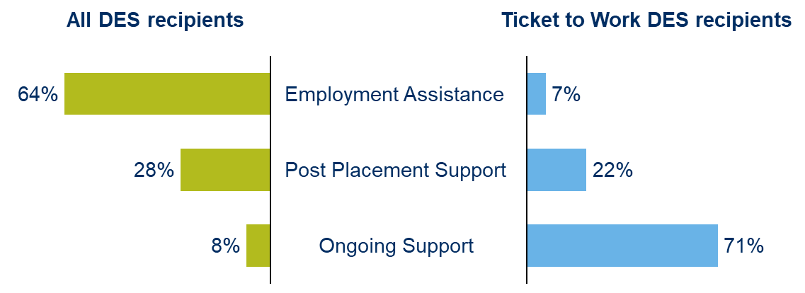
Figure 15: Percentage of DES participants in each of the phases of support
Ticket to Work has effects that both decrease and increase the total amounts that are paid by the government to providers supporting Ticket to Work participants. In particular:
- Ticket to Work may increase DES payments: 82% of Ticket to Work participants either work in open employment or are looking for work, compared to 42% in the business-as-usual scenario. As a result, there is a significantly more people being supported by DES to find and keep work.
- Ticket to Work may decrease DES payments: As shown in Figure 15, Ticket to Work participants who receive DES are more likely than other people with disability to be supported in the post-placement and ongoing support phases of their employment pathway. In addition, Ticket to Work research indicates that participants are staying in work for longer than is typical for people with disability (www.tickettowork.org.au). Where this is the case, there may be cost savings to government in the longer term as Ticket to Work participants are able to transition to independent workers without requirement for ongoing support.

Long Term Outcome 7. What benefits or costs can reasonably be expected to occur as a result of that outcome?
Ticket to Work increases the number of people in open employment and therefore it will increase the number of people receiving DES. However, Ticket to Work participants post school are more likely to be in the Post-Placement, Ongoing Support, or Independent Worker support phases.
Payment | Assumption | Source
Disability Employment Services | Payments to providers for DES recipients in Employment Assistance: $738 per quarter | DES agreement ESS1 rates
Disability Employment Services | Payments to providers for DES recipients in Post Placement Support: $5467 | DES agreement ESS1 rates
Disability Employment Services | Payments to providers for DES recipients in Medium Ongoing Support: $5352 | DES agreement ESS1 rates
Disability Employment Services | Payments to providers for DES recipients for one instance of Flexible Ongoing Support: $446 | DES agreement ESS1 rates
Disability Employment Services | Half those in ongoing support receive medium ongoing support, and half receive one instance of flexible ongoing support per year | DES agreement ESS1 rates
Disability Employment Services | 44% of people in Open Employment in the Ticket to Work scenario are Independent Workers  13% of people in Open Employment in the Business as Usual case are Independent Workers | DSS data on Ticket to Work participants found that about 49% of recipients who had previously received DES no longer receive it. DSS does not have data on their subsequent pathways, so we assume that 80% of these people go on to be Independent Workers. As no comparison data is available for all people with disability, we assume the likelihood of being an independent worker mirrors that of being in open employment.

Long Term Outcome 7. How many Ticket to Work participants experienced those outcomes, compared to what we would expect to see in a comparable group?

Workforce status | Receive DES? | Business as usual scenario | Ticket to Work scenario
In open employment
Post-placement support | Yes | 319 | 248
Ongoing Support | Yes | 145 | 791
Independent Worker | No | 67 | 806
In labour force, but unemployed
Employment Assistance | Yes | 804 | 804
In supported employment | No | 531 | 213
Not in labour force | No | 1,351 | 354
Total |  | 3,216 | 3,216

Long Term Outcome 7. Calculate the additional benefit generated by Ticket to Work
There is an average increase of about $1,100 on DES expenditure over three years per participant. This is the result of an increase in the share of people in the labour force, and the share of those people in the labour force who are in open employment.
Increase in DES costs over three years
Business as usual
  - Entire cohort $14.7m
  - $4,500 average per participant
Ticket to Work
  - Entire cohort $18.1m
  - $5,600 average per participant
Difference
  - Entire cohort $3.4m
  - $1,100 average per participant

Impact 8. Reduction in income support
Impact 8. What outcomes do participants experience as a result of being involved in Ticket to Work?
The outcomes that lead to a reduction in income support payments are:
- the increase in likelihood of employment increases incomes for people with disability, which may reduce the amount of income support they receive
- Increase in the likelihood of that employment being in an open workplace which increases the rates of pay that people with disability receive
Impact 8. What benefits or costs can reasonably be expected to occur as a result of that outcome?
There are three income support payments that may be affected by an increase in working hours or pay rates as a result of these changes to the employment status of Ticket to Work participants:
Disability support pension (DSP): DSP is paid to eligible people with disability at a rate of $926 per fortnight. The DSP reduces by 50c for each dollar earned over $174.
Youth allowance: youth allowance is paid to eligible people with disability living at home at a rate of $299.80 per fortnight, plus a disability supplement of $129.80. Youth allowance is reduced by 50c for each dollar earned over $437 per fortnight, and 60c per dollar earned over $524 per fortnight
Carer support payments: carer support payments are paid to the carers of people with disability. The calculation of the carer support payment is affected by many factors, including the income of the person with disability, their residential status, the carer’s income and the carer’s spouse’s income. Thus, there is the possibility that an increase in income for carers will reduce carer support payments.
As the survey data did not include interviews with carers it is not possible to accurately estimate what proportion of carers are receiving a carer support payment, nor whether an increase in working hours is likely to reduce that payment. There is also evidence that most disability carers receive no carer support payments (predominantly due to the income of their spouse). Given this, we have assumed that carer support payments will be unchanged as a result of any increase in work hours.
The assumptions underlying the income changes for this group are the same as those set out in the Impact 3 and Impact 4 (income for carers and participants respectively). In addition, we make the following assumption:
Payment:
Carer payment and carer allowance
Assumption:
No change in carer support payments and carer allowance as a result of increasing work and income
Source:
Conservative assumption given difficulty in assessing payment eligibility

Impact 8. How many Ticket to Work participants experienced those outcomes, compared to what we would expect to see in a comparable group?
The changes to the disability support pension and youth allowance are a direct result of the changes in income as a result of employment. The number of people in each scenario are set out below, along with the estimate of the amount of government pension and allowances they might receive.
Workforce status | Business as usual | Ticket to work | Govt pensions and allowances
In open employment
receiving youth allowance | 82 | 284 | $10,001
receiving DSP | 286 | 994 | $19,624
receiving no pension or allowance | 163 | 568 | $0
In supported employment
receiving youth allowance | 82 | 33 | $11,170
receiving DSP | 286 | 115 | $22,347
receiving no pension or allowance | 163 | 66 | $0
In labour force, but unemployed
receiving youth allowance | 247 | 247 | $11,170
receiving DSP | 371 | 371 | $24,081
receiving no pension or allowance | 186 | 186 | $0
Not in labour force
receiving youth allowance | 416 | 109 | $11,170
receiving DSP | 623 | 163 | $24,081
receiving no pension or allowance | 312 | 82 | $0
Total | 3216 | 3216

Impact 8. Calculate the additional benefit generated by Ticket to Work
The total cost of the disability support pension and youth allowance payments for the Ticket to Work scenario is estimated to be about $8.9m less over three years than it would have been under the ‘business as usual’ scenario, or an average of about $2800 per participant. This is set out below:
Reduction in income support payment over three years
Business as usual
- Entire cohort $135.2m
- Average per participant $42,100
Ticket to Work
- Entire cohort $126.3m
- Average per participant $39,300
Difference
- Entire cohort $8.9m
- Average per participant $2,800

Impact 9. Increase in tax revenue
Impact 9. What outcomes do participants experience as a result of being involved in Ticket to Work?
The increase in work outlined in Impact 3 and Impact 4 may increase tax revenues for the government. There are two sources of increased tax revenue:
- People with disability: who increase work, or get paid more as a result of being in open employment.
- Carers: who increase work as the people they care for return to work.
Impact 9. What fiscal benefits or costs can reasonably be expected to occur as a result of that outcome?
The increase in work outlined in Impact 3 and Impact 4 may increase tax revenues for the government. There are two sources of increased tax revenue:
- People with disability: at the average wage, and average number of hours worked per week, people with disability do not earn enough to cross the income tax threshold, so there are no modelled revenues from people with disability.
- Carers: who increase work are assumed to pay a marginal 19.5% of tax on wages, and 15% on superannuation contributions.
The remaining assumptions are the same as those outlined in Impact 3 and Impact 4.
Impact 9. How many Ticket to Work participants experienced those outcomes, compared to what we would expect to see in a comparable group?
Business as usual
- PWD who work 1,062
- Carers who want to increase work 503
- No. who are able to increase hours 475
Ticket to Work
- PWD who work 2,058
- Carers who want to increase work 974
- No. who are able to increase hours 921

Impact 9: calculate the additional benefit generated by Ticket to Work
The following sets out the anticipated amount of tax paid for a carer who increases work hours as a result of the person they care for taking up work. The difference between the average increase in work hours per week is driven by the fact that Ticket to Work participants are more likely to be in open employment, and therefore work longer hours than the business as usual participants. The increased work hours mean that carers are able to work more.
Business as usual
- Hourly rate (inc super) 31.93
- Weighted avg. increase in 9.5
- Annual increase in tax paid per annum 3,000
Ticket to Work
- Hourly rate (inc super) 31.93
- Weighted avg. increase in 8.3
- Annual increase in tax paid per annum 2,600

Impact 9. Calculate the additional benefit generated by Ticket to Work
Increase in tax revenue over three years
Business as usual
  - Entire cohort $4.3
  - Average per participant $1,300
Ticket to Work
  - Entire cohort $7.3m
  - Average per participant $2,200
Difference
  - Entire cohort $3.0m
  - Average per participant $900

Impact 10. Reduction in Disability Employment Assistance grants
Impact 10. What outcomes do participants experience as a result of being involved in Ticket to Work?
Disability Employment Assistance grants are provided to Australian Disability Enterprises for each person with disability they employ. Therefore the amount the government will pay in grants will be reduced if there are fewer people in supported employment.
Impact 10. What fiscal benefits or costs can reasonably be expected to occur as a result of that outcome?
Disability Employment Assistance grants are case-based funding grants are made to Australian Disability Enterprises that employ people with disability. These payments are made on a per-employee basis. The following table sets out these assumptions.
Payment | Assumption | Source
Disability Employment Assistance | 100% of people in supported employment are at an ADE that received grants
Disability Employment Assistance | ADEs employing all people with disability engaged in supported employment are paid an average Case Based Funding amount of $13,836 ($12.09 per hour) | DSS Case Based Funding pricing tables 2019-20 and NDS data

Impact 10. How many Ticket to Work participants experienced those outcomes, compared to what we would expect to see in a comparable group?
These grants are only paid where a person is in supported employment. There are about 280 fewer people in supported employment in the ‘Ticket to Work’ scenario, compared to business as usual.
People in supported employment
  - Business as usual 531
  - Ticket to Work 213

Impact 10. Calculate the additional benefit generated by Ticket to Work
As a result of the significant reduction in the number of people in supported employment, there is an average reduction in Disability Employment Assistance grants of $2,300 per participant over the three-year impact period.
Increase in Disability Employment Assistance Case Based Funding over three years
Business as usual
  - Entire cohort $22m
  - Average per participant $6,800
Ticket to Work
  - Entire cohort $8.8m
  - Average per participant $2,700
Difference
  - Entire cohort $13.2m
  - Average per participant $4,100

Sensitivity testing
The following table outlines five sensitivity tests of core underlying assumptions
Table 4 Sensitivity testing
 | Rationale | Base assumption | New assumption | New valuation | Change from base case
Base case |  |  |  | $27,100
Sensitivity test 1: NDIS plans | NDIS was only partially rolled out during survey in 2018, so some participants who would be eligible might not have had a plan at time of survey | 56% of participants have NDIS plan | 80% of participants have NDIS plan | $28,800 | $1700
Sensitivity test 2: NDIS usage | Rates are based on an estimate of impact on NDIS usage. | 50% reduction in NDIS group supports for each hour of work, 30% reduction in individual supports if go out as much as wanted | 10% reduction in NDIS group supports for each hour of work, 10% reduction in individual supports if go out as much as wanted | $23,900 | ($3200)
Sensitivity test 3: 10 year impact period | There is evidence that early intervention has long-term impacts on employment. Discount and drop-off added to reflect longer time period. | 3 year impact period | 10 year impact period, 6.5% social discount rate, 10% annual drop-off | $50,000 | $22,900

Acknowledgements
Ticket to Work would like to thank all the young people that participated in the ARTD 2019 report that informed this paper. They would also like to acknowledge their supporters who share a common commitment to improving school to work transition for students with disability. These supporters include members of the Ticket to Work Network, Paul Ramsay Foundation, Gandel Philanthropy and Barr Family Foundation.

Bibliography
Abelson, Peter and Dalton, Tim, Choosing the Social Discount Rate for Australia (March 2018). Australian Economic Review, Vol. 51, Issue 1, pp. 52-67, 2018. Available at SSRNor http://dx.doi.org/10.1111/1467-8462.12254
ABS 2016 4431.0.55.003 - Experiences of Violence and Personal Safety of People with Disability, 2016 https://www.abs.gov.au/AUSSTATS/abs@.nsf/Lookup/4431.0.55.003Main+Features12016?OpenDocument
ABS 2019a 6302.0 - Average Weekly Earnings, Australia, May 2019 https://www.abs.gov.au/ausstats/abs%40.nsf/mediareleasesbyCatalogue/030E8BEF4B0B915ECA2582EA00193B04?OpenDocument
ABS 2019b 6202.0 - Labour Force, Australia, Jul 2019 at abs.gov.au/ausstats/abs
Athanasou, J. A., Murphy, G. C., & Mpofu, E. (2019). The impact of disabilities on earning or learning in Australia and the implications for career development. Australian Journal of Career Development, 28(2), 103–111 at dio.org/10.1177
Australian Institute for Health and Welfare (2018) The Health of Australia’s Prisoners at aihw.gov.au
Deloitte Access Economics. 2011. “The Economic Benefits of Increasing Employment for People with Disability.” Deloitte.com/documents economic benefits increasing employment for people with disability.
DSS 2017 Discussion paper: Ensuring a strong future for supported employment at engage dss.gov.au/discussion paper ensuring for strong future for supported employment.
Holland, Shasta, and Peter Persson. 2011. “Intellectual Disability in the Victorian Prison System: Characteristics of Prisoners with an Intellectual Disability Released from Prison in 2003–2006.” Psychology, Crime & Law 17 (1): 25–41.
Lamb, S., and S. Huo. 2017. “Counting the Costs of Lost Opportunity in Australian Education (Vol. Report No. 02/2017).” Melbourne: Mitchell Institute.
Long, Brendan. 2015. “An Estimate of the Economic Effects of the Implementation of the National Disability Insurance Scheme.” At cadr publications files ndis economic benefits.
McKee-Ryan, Frances, Zhaoli Song, Connie R. Wanberg, and Angelo J. Kinicki. 2005. “Psychological and Physical Well-Being during Unemployment: A Meta-Analytic Study.” Journal of Applied Psychology 90 (1): 53.
National Disability Insurance Agency. n.d. “Employment Outcomes 30 June 2018: Participants, Families and Carers.” At NDIS.gov.au/media
NDS. 2011. “The Economics Benefits of Disability Employment Estimates of the Labour Supply Impacts of the OECD Integration Scenario and the National Disability Insurance Scheme Using SDAC 2009.”
OECD. 2010. Sickness, Disability and Work: Breaking the Barriers.at oecd/library.org
Polidano, C and Mavromaras, K. (2010), ‘The role of vocational education and training in the labour market outcomes of people with disabilities’, NCVER,
Productivity Commission. 2011. “Disability Care and Support Productivity Commission Inquiry Report Volume 2.” At pc.gov.au inquires completed disability support report
PWC. 2011. “Disability Expectations Investing in a Better Life, a Stronger Australia.” Pwc.com.au/industry government assets disability in Australia.
Yu, Peng. 2009. “Social Participation of Youth with Disability: A Study with the First Seven Waves of HILDA.” In HILDA Survey Research Conference, 16–17.

